|  |  |
| --- | --- |
| No. of Pages | 5 |
| No. of Questions | 9 |

**Student Name: _________________________________________ ID: ____________________**

**Department of Computer Science and Engineering**

**Final Examination FALL 2015**

**CSE420: Compiler Design**

**Total Marks: 60 Time Allowed: 2.15 Hour**

|  |
| --- |
| * You HAVE TO RETURN this question paper and the answer script at the end of the exam. Your script will not be checked unless you do so. * You are not allowed to communicate with any other candidate in any way what so ever. |

**Section 01 (There are 4 questions, answer any 3 out of them) [30 points]**

1. a) Convert the following NFA to an equivalent DFA using the subset construction methodology. **[8 points]**

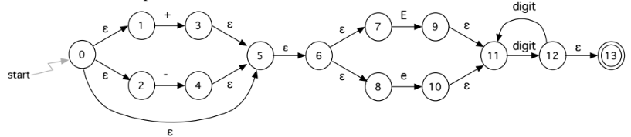

b) Define display register with proper example. [2 points]

2. A syntax directed definition for deriving the decimal value of a binary number is:

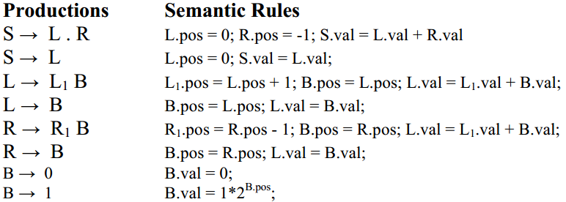

a) Draw an annotated parse tree for the sentence: 101.101 **[6 points]**

b) Draw the dependency graph (separately) for the parse tree of (a) **[4 points]**

3. Consider the following sequence of 3-address codes:

|  |  |
| --- | --- |
|  |  |

1. Draw the control flow graph by defining each individual basic block. **[3 points]**
2. Provide Use set and Define set of each basic block. **[3 points]**
3. Calculate the Live set for each consecutive block. **[2 points]**
4. What do you understand by dead code? **[2 points]**

4. With the help of following code segment describe the “next-use” algorithm. **[10 points]**

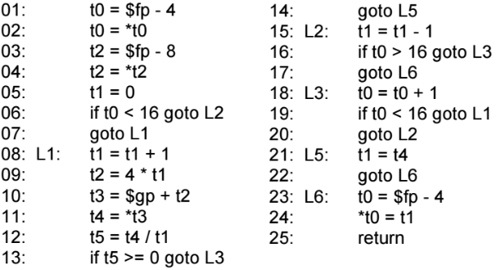

**Section 02: (There are 2 questions, answer only 1 out of them) [12 points]**

1. Considering the alphabet Σ = {0,1} construct a Deterministic-Finite Automaton (DFA) using the first-, last- and follow-pos sets that is able to recognize the sentences generated by the regular expression (1*01*0)*(1|(01))*. **[12 points]**

2. a) Convert the following DFA to RE. **[4 points]**

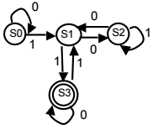

b) What do you understand by Common Sub expression Elimination? **[2 points]**

c) What are the intermediate languages types? **[2 points]**

d) What is back-patching? What is the advantage of back-patching? Define the functions and lists used in back-patching. **[4 points]**

**Section 03: [18 points]**

Consider the Context-Free Grammar (CFG) depicted below where “begin”, “end” and “x” are all terminal symbols of the grammar and “Stat” is considered the starting symbol for this grammar.

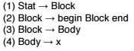

For this grammar answer the following questions:

a) Compute the set of LR(1) items for this grammar and draw the corresponding DFA. **[8 points]**

b) Construct the corresponding LR parsing table. **[4 points]**

c) Show the stack contents, the input and the rules used during parsing for the input string “begin begin x end end $”. **[4 points]**

d) Define Register Descriptor and Variable Descriptor. **[2 points]**